# Extra Credit Assignment 1 COMSW4111

**UNI: jc4833 Name: Jiahe Chen**

**Screenshot of Code:**

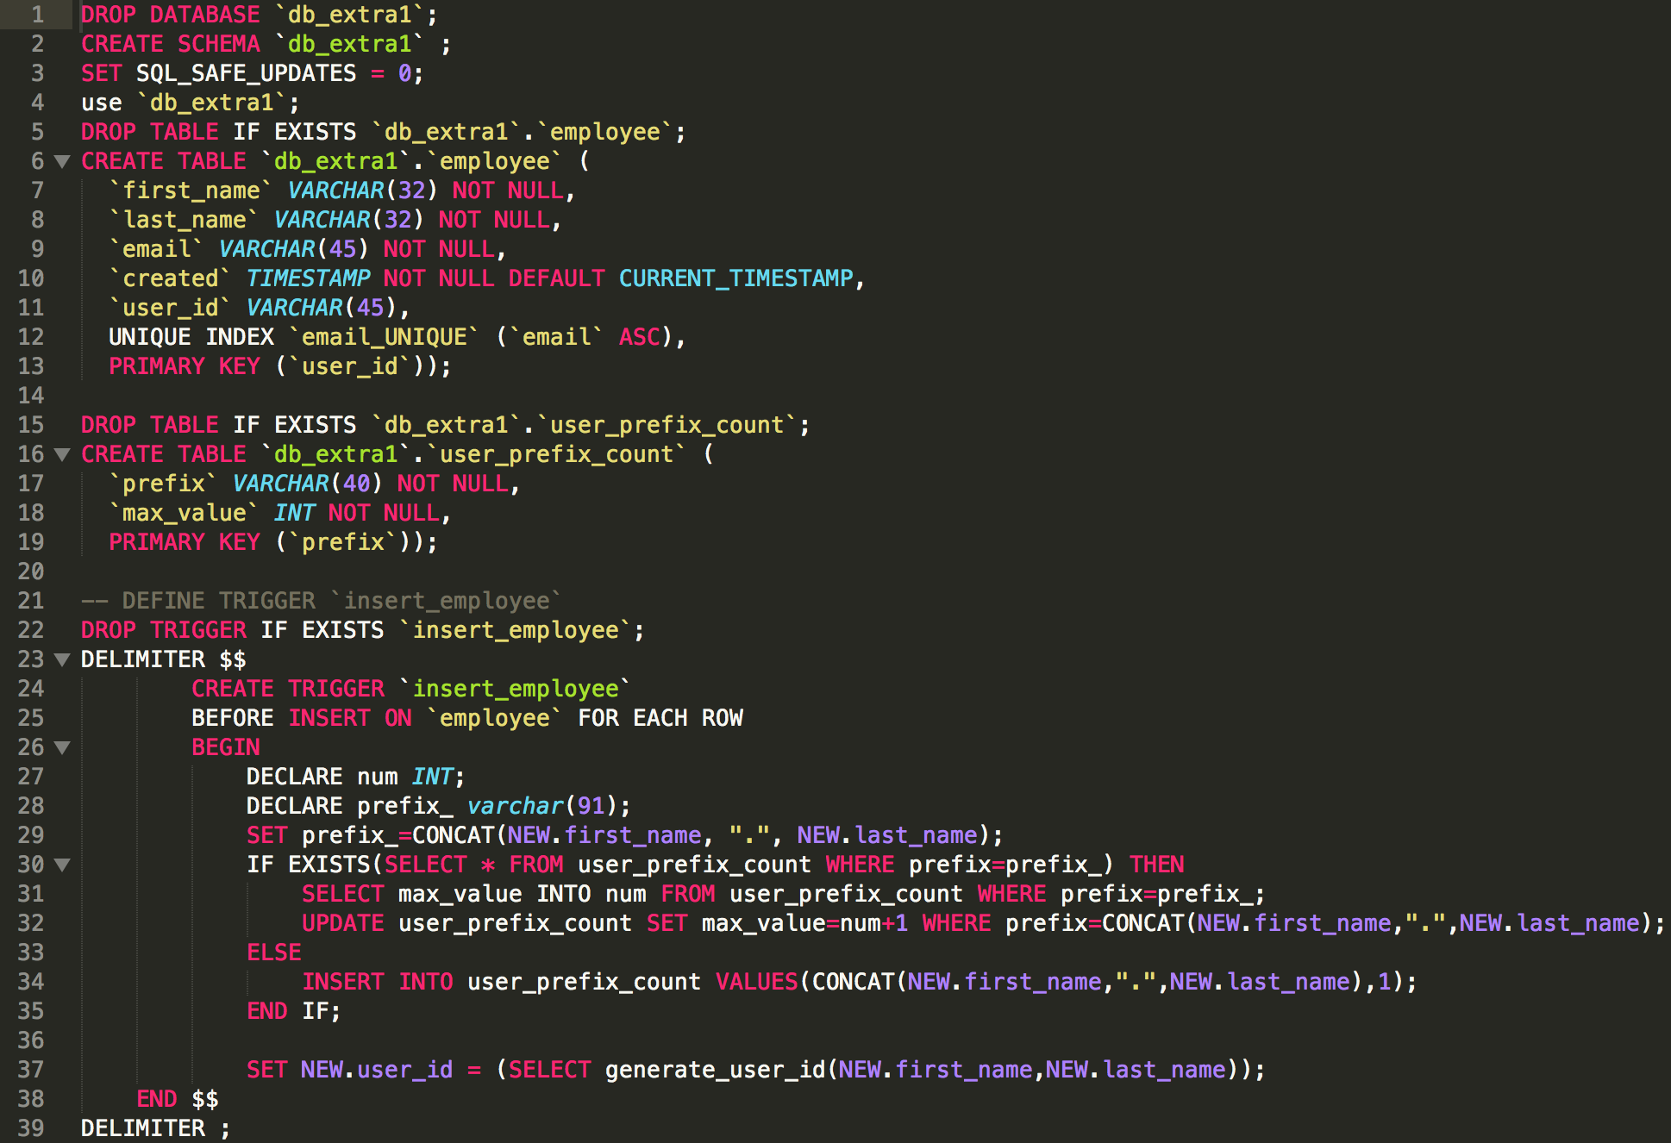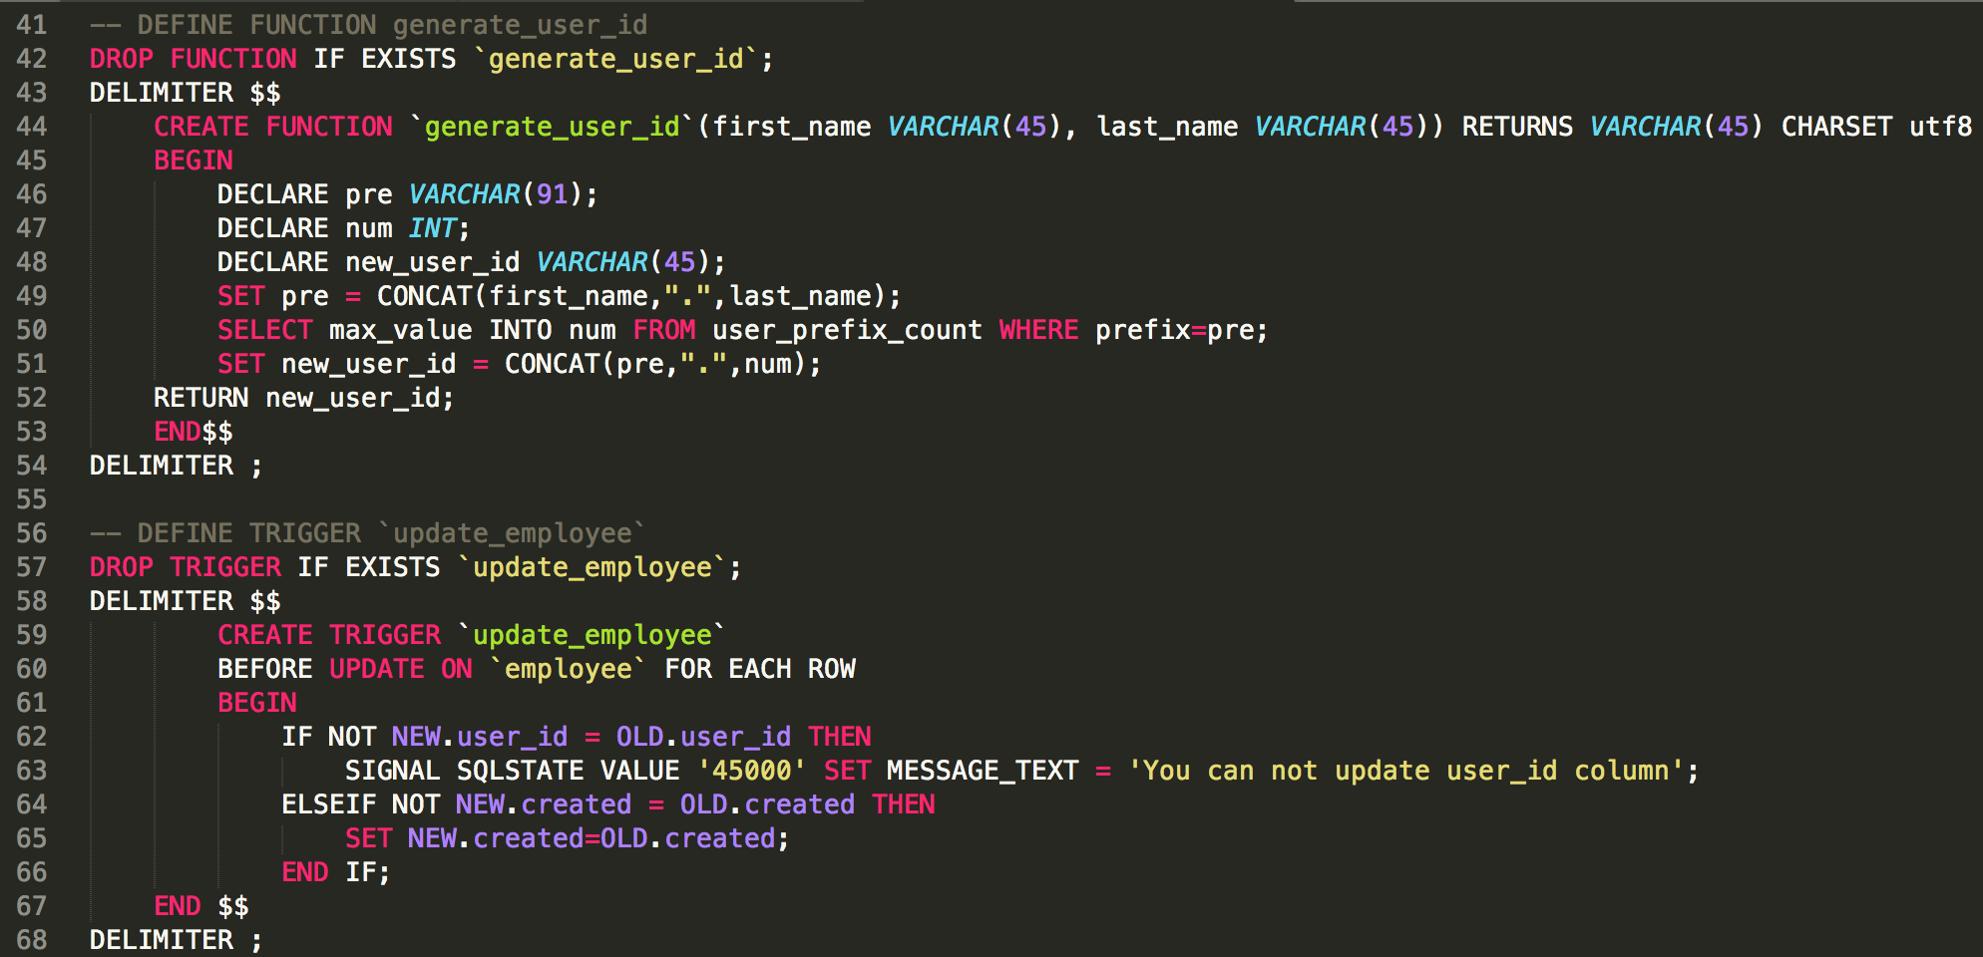

**Test 1:**

Loading the data should result in the following format because of the generated columns and triggers (note: your dates will be the day and time you load the data).

Code:

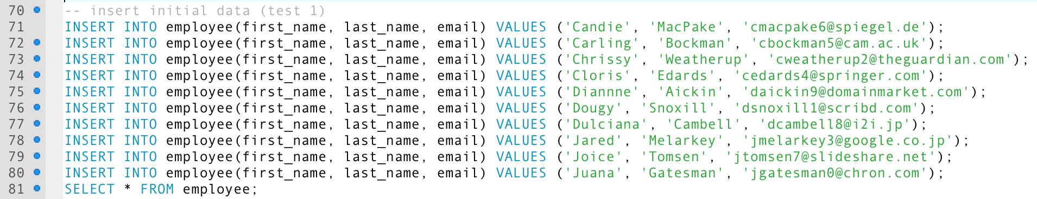

Screenshot:

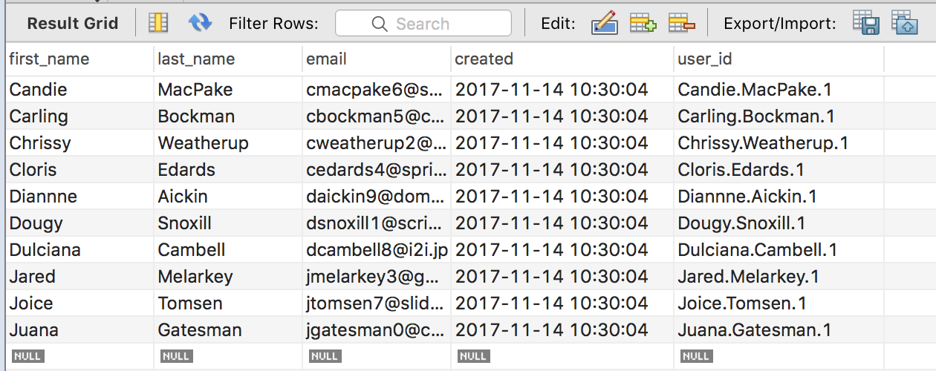

**Test 2:**

Execute an update to set "Dougy Snoxill" first name to "Douglas", and set the created time to the current time. The resulting tuple, should be

Code:



Screenshot:

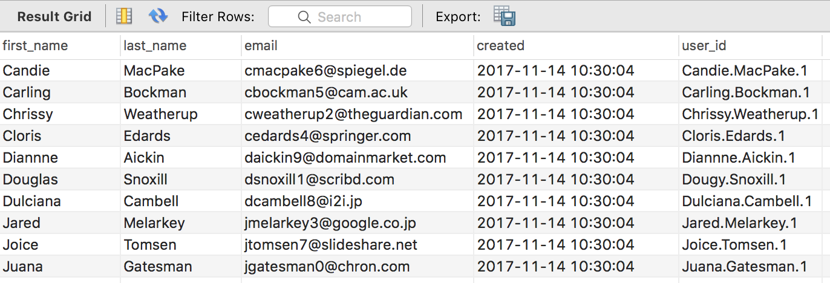

**Test 3:**

Attempt to INSERT a tuple with a duplicate email. This should faily.

Code:



Screenshot:



**Test 4:**

Attempt to update Douglas Snoxill's user ID. This should fail.

Code:



Screenshot:



**Test 5:**

Insert John Smith’s information, then delete some, and then insert other John Smith’s information.

Code:

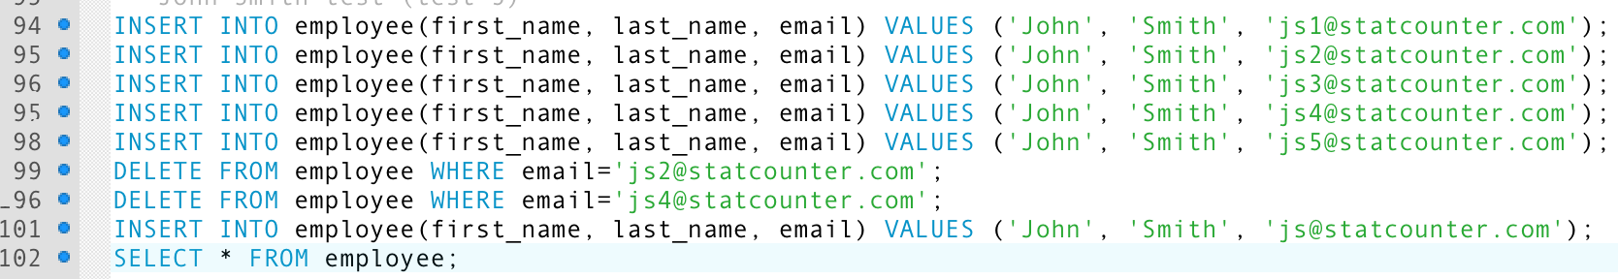

Screenshot:

